STREAMING INSTRUCTIONS
IMPORTANT DATES:
TECH TEST DAY: Thursday, September 17, 2020 | 10:00AM – 5:00PM
WPC will be live on YouTube from 10am – 5pm for you to test the stream on your devices.
2020 VIRTUAL ANNUAL DINNER: Friday, September 25, 2020
3:00pm: Private Q&A Meetings
6:00pm: VIP Panel Discussion
7:00pm: Main Event

TEST DAY EVENT CODE:
TEST DAY | September 17: “White Cylinder Blue Light”

TABLE OF CONTENTS
- How to set up your new Amazon Firestick
- How to join WPC’s Virtual Annual Dinner on TEST DAY on September 17th …
  - With your Firestick
  - Using your computer, smartphone or tablet
  - Through the YouTube app on your smart TV
  - By streaming your computer to your smart TV
  - By using the YouTube app on your Apple TV
  - By streaming your iPhone to your Apple TV
  - By streaming your Mac to your Apple TV

How to set up your new Amazon Firestick
- Plug the USB Micro cable into the power adapter.
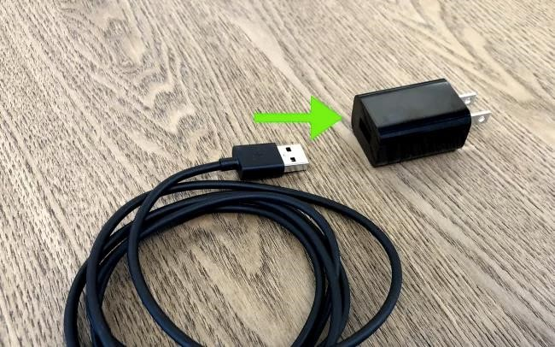

- Plug the other end into the Fire TV Stick.
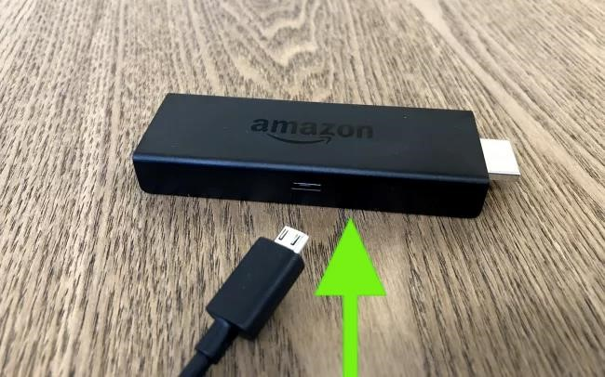

- Plug the Fire TV Stick into an HDMI port in your TV.
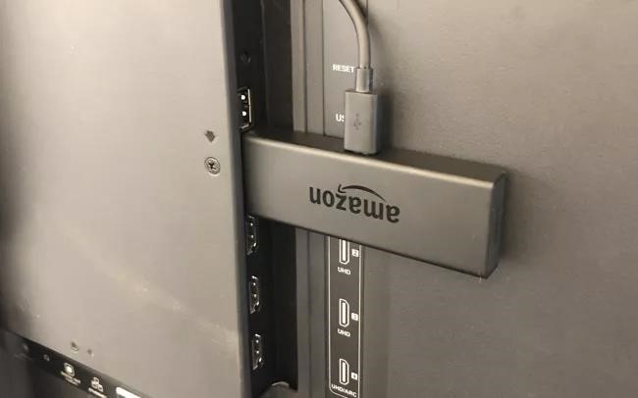

- Press Home on your remote – a screen will pop up on your TV to prompt you.
- Press Play/Pause on your remote as prompted.
- Select Your Language.
- Select your Wi-Fi network.
- Enter your password and select Connect.
- Select Register or Create an Account (Note, you do not have to be an Amazon Prime Member, but you do need to have or create an Amazon account).
- Enter your Amazon login ID and click Next. If you selected Create an Account, you will be creating that ID.
- Enter your password and select Sign In.
- Confirm it's your account that's signed in.
- Select Yes or No to opt in or out of storing connected network passwords with Amazon.
- Opt-in or out of parental controls.
- Sign up for Prime or decline.
- Select “Choose Apps” to walk through Amazon's app downloads or click “No Thanks” to skip past. (You can download the YouTube app at this point – it will be under the social media category - but if you choose to skip past, there are additional steps you can do after setting up your Firestick. These are listed below.)
Select the popular services you want if applicable and click right to TV channels
- Select the TV channel apps you want if applicable and click right to sports apps 18. Select the sports apps you want if applicable and click right to the featured apps.
- Select the featured services you want if applicable and click Play to proceed.
- Click Download to download the apps you have chosen.
- You’re Firestick is all set up!

How to Join WPC's Virtual Annual Dinner …
Event Codes are listed on the cover page of this document and will be emailed out prior to the event

…Using your Firestick
- Open the “YouTube” app and select “Download” if necessary
- In the YouTube app, navigate to the right side of the screen and select “Search” 3. Use the arrows on your firestick remote to type in the event code and click search
a. You should see and select the “&123” on the left side of the keyboard to key in “2020” 4. Open the first search result and enjoy the show!

…using your computer, smartphone, or tablet
- Open your internet browser
- Visit www.wpcdinner.com
- Click “Go Live” at the top of your screen (or “Tech Test Day” for 9/17)
- Click on the level of access per your ticket or sponsorship level
- Use the password sent to you via email and access the page 6. Click on the link you want to access
7. Enjoy the show!
Tip: Make sure your device is plugged into power

…through the YouTube app on your smart TV
- Turn your TV on and go to your applications list (Netflix, Hulu, etc)
- Open the YouTube app.
- In YouTube, go to search and type in the event code, click search
- Click on the first video that pops up.
- To enlarge your screen, click anywhere on the viewing screen and click on the enlarge icon located in the right-hand corner.
- Welcome to WPC’s 2020 Virtual Annual Dinner!
… by streaming your computer to YouTube on your smart TV
- Visit this link: https://www.youtube.com/pair
- Follow instructions on the page to link to your TV
- In the search bar, type in the event code
- Click on the video, enlarge screen and enjoy the show
Tip: make sure your computer is connected to power
… by using the YouTube app on your Apple TV:
- If YouTube is not already installed on your Apple TV, visit the App Store and Download YouTube
- After downloading, you can open up YouTube and search for the event code and click search.
- This will take you to the YouTube page that is showing WPC’s Virtual Annual Dinner.
- Welcome to WPC’s 2020 Virtual Annual Dinner!

… By streaming your iPhone to your Apple TV
- Swipe up from the bottom of your iPhone to view Control Center
- Tap on Screen Mirroring and then choose your Apple TV
- You may be required to enter an AirPlay code for the Apple TV you are connecting to. This code will appear on the TV Screen attached to the Apple TV
- Open your internet browser and type in youtube.com
- In the Search bar, enter your event code and click search
- This will take you to the YouTube page that is showing WPC’s Virtual Annual Dinner.
- If you rotate your iPhone into landscape mode, you should be able to view the web using the full screen of your TV
- Welcome to WPC’s 2020 Virtual Annual Dinner!

… by streaming your Mac to your Apple TV
- Click on the AirPlay icon from the menu bar at the top of the screen (a triangle pointing into a box)
- Choose your Apple TV from the options
- You may be required to enter an AirPlay code for the Apple TV you are connecting too. This code will appear on the TV Screen attached to the Apple TV.
- Your Mac display may alter so that it is optimized for the Apple TV (This will make everything look smaller on your Mac)
- Once you connect, your Mac screen will mirror on the TV.
- Open up your browser and type in YouTube.com
- In the Search bar, enter your event code and click search
- This will take you to the YouTube page that is showing WPC’s Virtual Annual Dinner.
- Alternatively, you can access the YouTube page on your laptop and connect your laptop to your TV via an HDMI cable.
- Welcome to WPC’s 2020 Virtual Annual Dinner!

